**MACHINE LEARNING ASSIGNMENT 1**

Name: Pranay Paul Thirumala Reddy

ID: 700741744

A. Using NumPy create random vector of size 15 having only Integers in the range 1-20.

1. Reshape the array to 3 by 5

2. Print array shape.

3. Replace the max in each row by 0

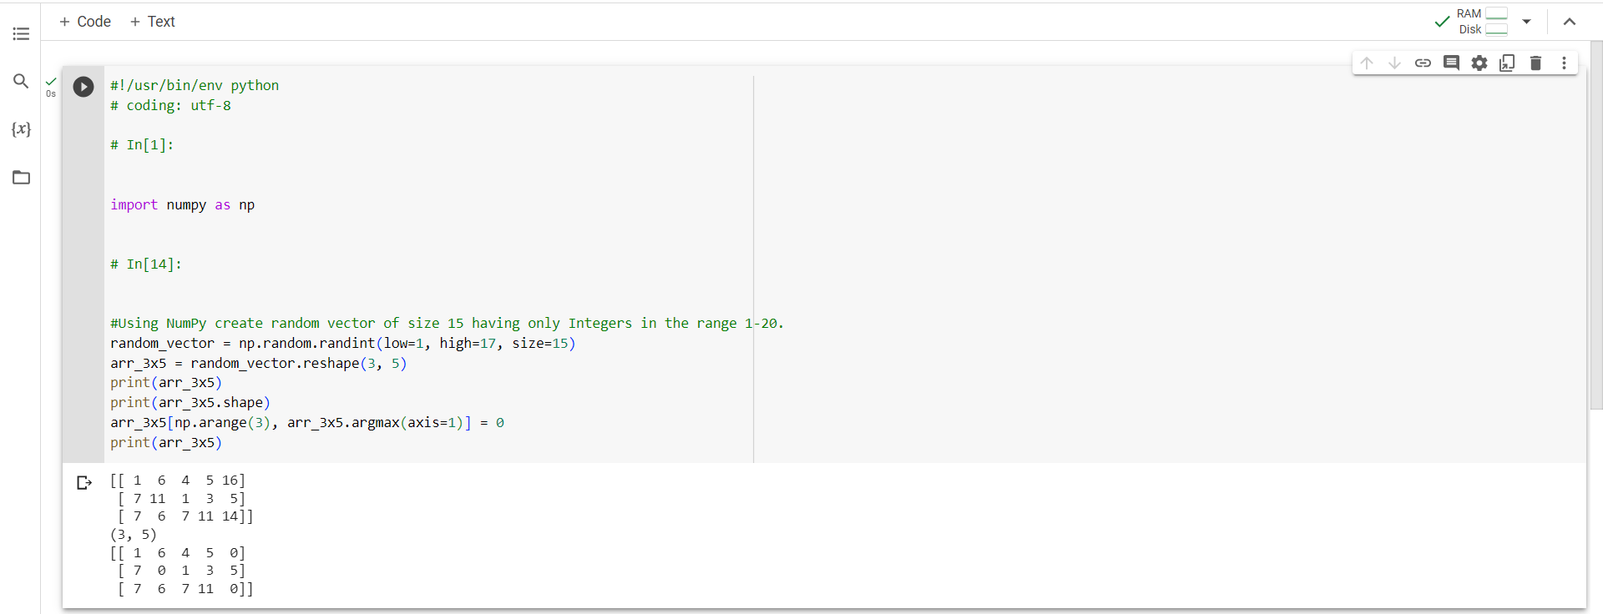

Create a 2-dimensional array of size 4 x 3 (composed of 4-byte integer elements), also print the shape, type and data type of the array.

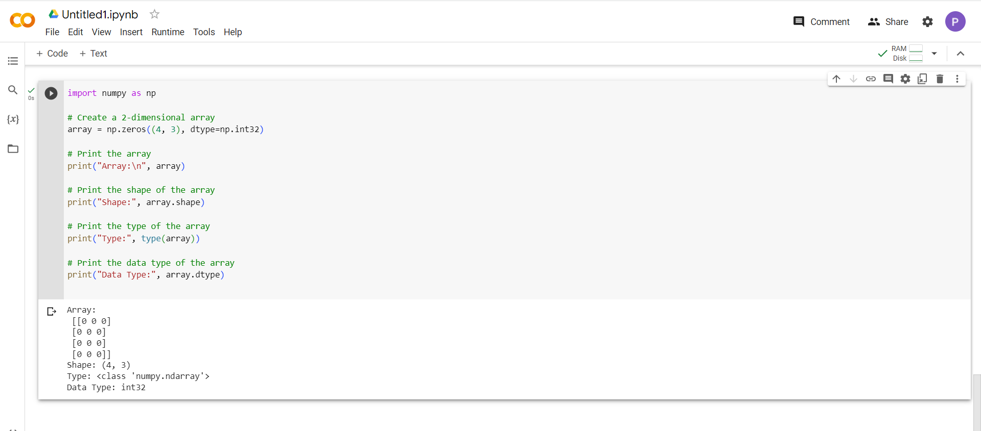

Write a program to compute the eigenvalues and right eigenvectors of a given square array given below: [[ 3 -2] [ 1 0]]

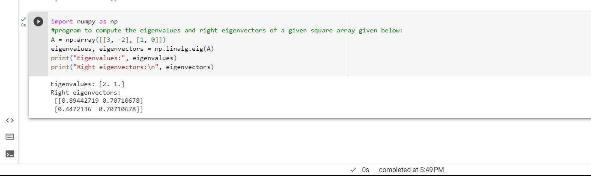

Compute the sum of the diagonal element of a given array. [[0 1 2] [3 4 5]]

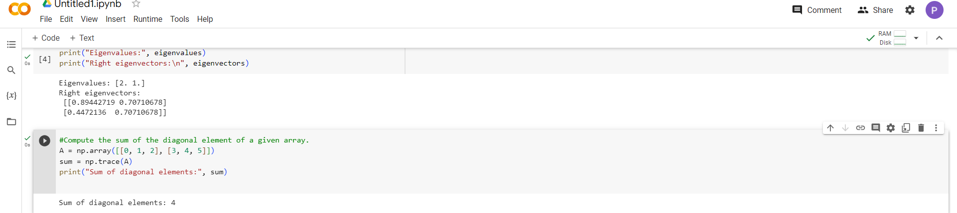

d. Write a NumPy program to create a new shape to an array without changing its data.

Reshape 3x2: [[1 2] [3 4] [5 6]]

Reshape 2x3: [[1 2 3] [4 5 6]]

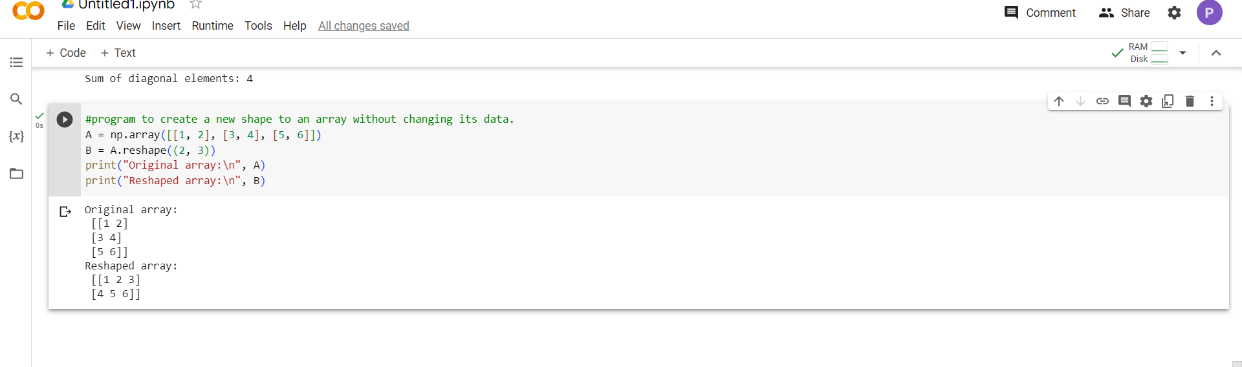

Write a Python programming to create a below chart of the popularity of programming Languages.

Programming languages: Java, Python, PHP, JavaScript, C#, C++

Popularity: 22.2, 17.6, 8.8, 8, 7.7, 6.7

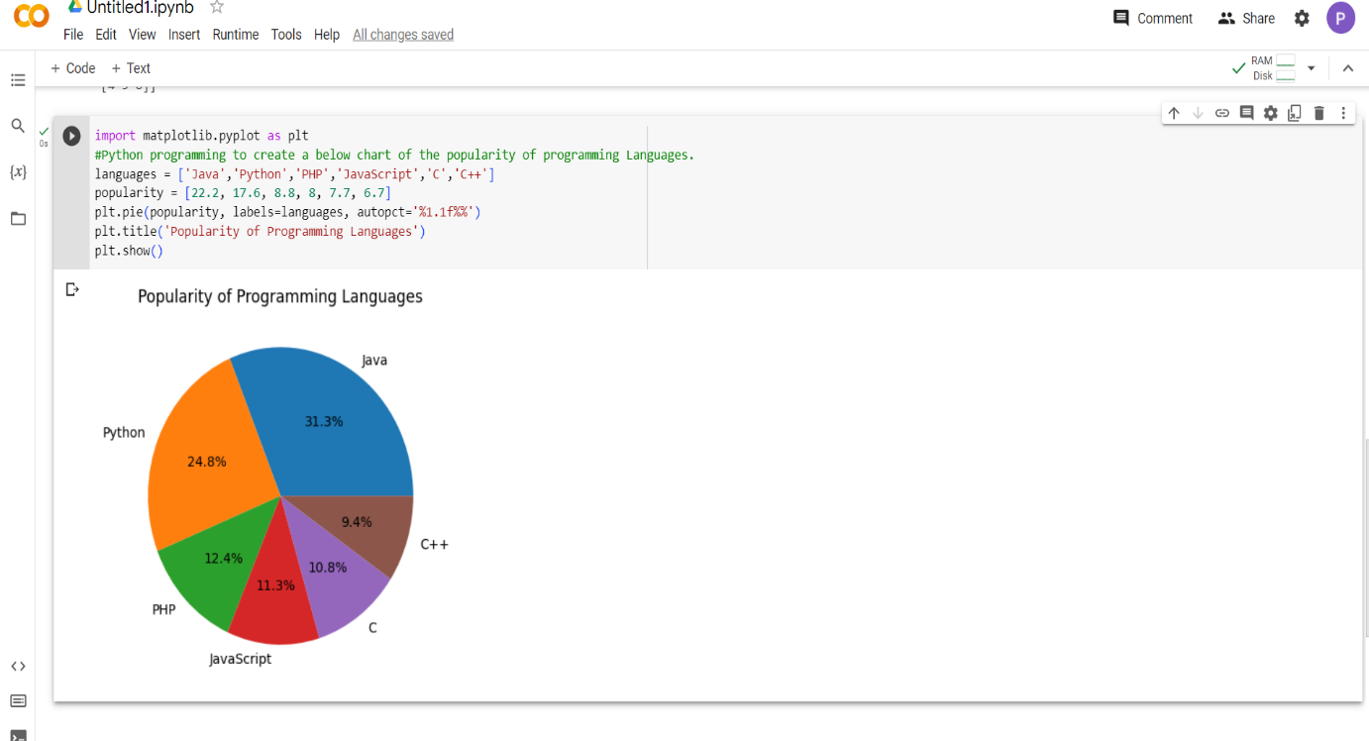

GITHUB LINK: